Project title: Visualization of Air Quality Map on Web (Smart City)

Number of students (minimum 2): 2-3
Project duration (1-6 months): 6 months
Project frame (Bachelor/Master, small project): Bachelor/Master

Background:

Air pollution is one of the global problems of modern world. According to World Health Organization only 9% of the world’s total population can breathe clean air. Particulate Matter, which is the mixture of liquid and solid particles having diameters less than 10 μm is one of the pollutants in air. Particulate Matter is mostly produced from burning reactions in factories, vehicles or homes. Several studies have shown the deleterious impact of particulate matter to public health and environment. The increase of particulate matter in air has been linked to many health problems such as lung disease, asthma, respiratory insufficiency, mortality in infants, heart attacks, cancer and etc [1]. Developed countries have regulations for monitoring the air quality and conventional bulky stations are employed for that purpose. These stations are high-cost and they have limited spatial resolution. In order to overcome the limitations of existing monitoring systems, alternative approaches have been studied [2]. Opsentia, as a research and development company, is working on creating new solutions for environmental sensing. A new particulate matter sensor is designed, produced and tested for monitoring air quality. The developed system is low-cost and has high spatial resolution. The sensor network is able to communicate with cloud computing and allows remote data analysis.

The Challenge:

The goal of this project is to develop a web application which uses sensor readings together with the GPS data and visualize particulate matter readings on street maps as a colour graph (Figure 1). The user can check the map online and see the time frame and sensor measurements.
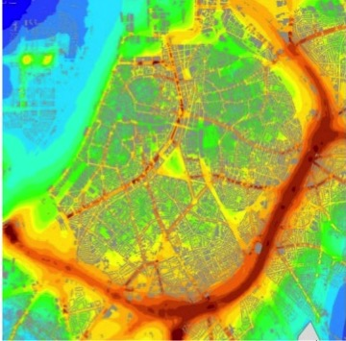
Figure 1: An illustration of a color map showing sensor readings street-wise.

The company:

"Opsentia R&D"

Supervisor(s):

Kutay İçöz – main supervisor (kutay.icoz@agu.edu.tr)
Ebru İçöz – co-supervisor (opsentia@gmail.com)

Kutay İçöz works as an Associate Professor at AGU, Turkey. His main field of interest is sensor development for medicine and environmental applications. Before joining AGU and establishing Opsentia, he completed his PhD studies at Purdue University, and worked at Intel Inc.

Ebru İçöz is both CTO for Opsentia and software engineer. Her fields of interest include web applications, data analysis and smart cities.

Candidate background:

- The candidates are required to have programming skills

References

[1] | W. Zhang, C. N. Qian, and Y. X. Zeng, “Air pollution: A smoking gun for cancer,” Chinese Journal of Cancer, 2014
[2] | J. Su, “Portable and sensitive air pollution monitoring,” Light: Science and Applications. 2018

