Theme: Display Location Information using Wireless Communication Systems

Number of students: minimum 2 students
Project duration: 3 to 12 months
Project frame: Bachelor, Masters Research project with 4 to 6 months
Work load: 12 to 30 ECTS

Background:

- In many governmental offices, it is hard to reach correct location and correct person for the citizens and workers.
- Different solutions are produced and different technologies are being used in daily life for the need of finding a place in indoor and outdoor areas. The main problems regarding the approaches developed for indoor areas are the modelling of the closed space and determining the position of the user.

- Navigation systems developed for indoor spaces couldn’t achieve the success rates that GPS technologies did for outdoor spaces.

Which technological structures can be used for locating moving objects within a defined area?

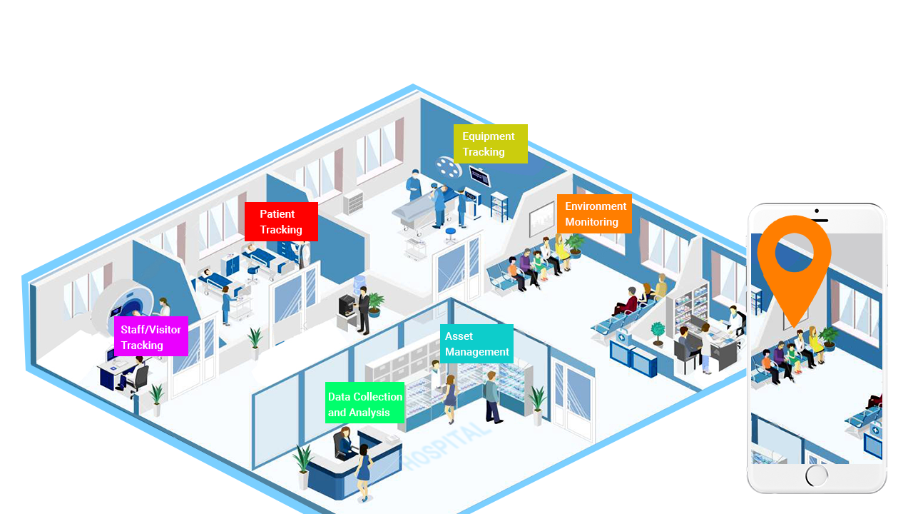

Figure 1: Overview of indoor navigation system

The challenge:
The main objective of this project is to determine the location using wireless technologies and to minimize the error rate, while displaying this data on the defined map and to present it to the user. The tasks include:
  - To understand and work on the wireless communication system to be used in the project.
  - Using mathematical models in algorithms that will be used for location determination.
  - Simulation and interpretation of the data on the map.

The company:
B&B operates in consultancy and development processes on technology and information systems. The company provides IOT, Network and System solutions.

Supervisors:

Candidate background:
- MQTT , RF, Simulation on Map, Mathematical Modelling

References and complementary description:

[1] O.Kayıs, Y. Cakmak, S. Utkup,Indoor navigation system with using mobile devices", Denizli, Turkey

[2] https://www.pathpartnertech.com/wp-content/uploads/2019/06/UWB-based-Indoor-Positioning.png

